# Week 07: Coursework

## Spring Framework

1. Fork and clone the following Github repository.

<https://github.com/busyQA-java-developer/busyqa-07-spring-3-coursework-initial.git>

1. Import the Gradle project into Eclipse.
2. This project is a small web application based on the busyqa-07-spring-2-course-complete project that we coded in class. This application adds the Role property to the User. We have three roles: Admin, User and Guest, but a User can have one role only.

We added the *Role* column to the *Users’ Table in the picture below*.

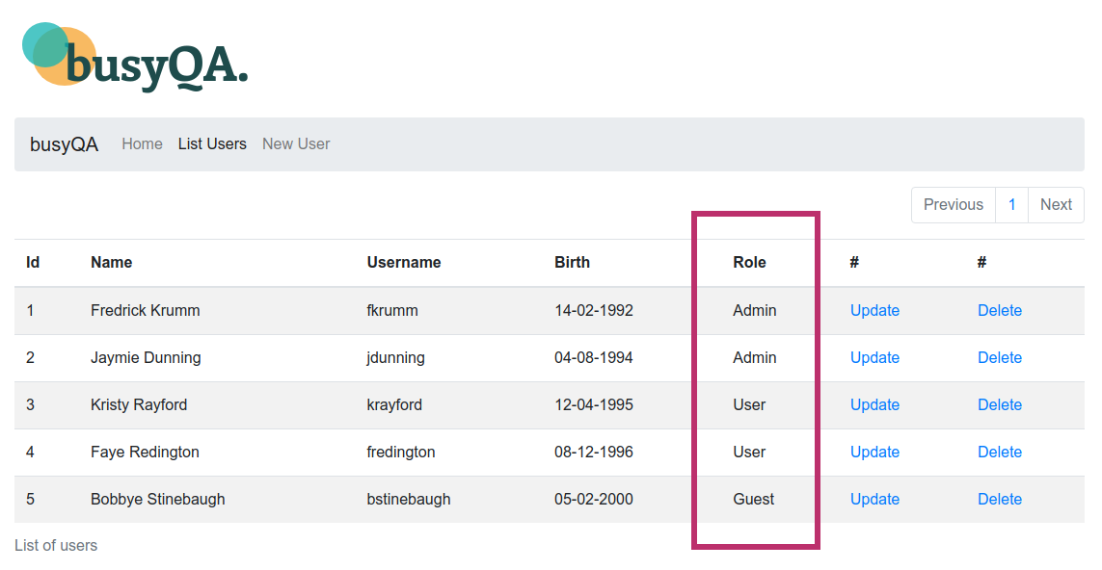

The *New User* form has a new field to select the *Role* from a dropdown box in the following picture. The *Update User* form has a new field to choose the *Role* as well.

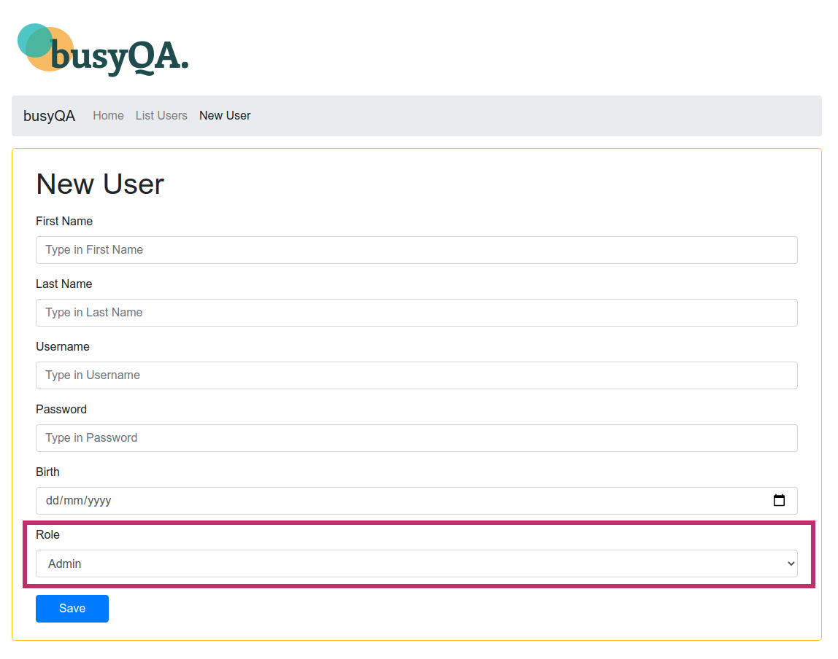Please check the UserBean and the RoleBean classes in the bean package of the project. Note that the UserBean class has a RoleBean property. Also, note that in the UserDao constructor(), we pass a RoleBean when creating a UserBean.

**Note.-** This project has four HTML templates with the Thymeleaf template engine. These templates require no modifications unless you want to customize them. However, the UserController needs some coding. The changes are detailed inside the UserController from A to H. You can use the busyqa-07-spring-2-course-complete project that we coded in class as a reference.

1. After completing the project, test it, commit and push your changes to your GitHub repository.
2. You can find the solution for the project in the Github repo:

<https://github.com/busyQA-java-developer/busyqa-07-spring-4-coursework-complete.git>

// End